**SALES DATA MySQL QUERIES**

**A ->Problem Statement for MySQL:**

1. **Sales by Productline:**

**->** select productline ,sum(sales) from sales_data group by productline order by sum(sales) desc;

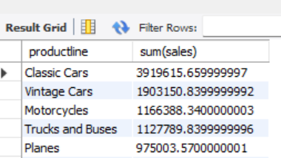

**2. Sales by Year:**

-> select year_id , sum(sales) from sales_data group by year_id order by sum(sales) desc;

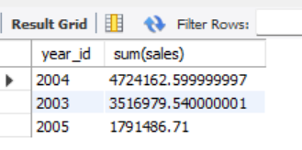

1. **Sales by Dealsize:**

**->** select dealsize , sum(sales) from sales_data group by dealsize order by sum(sales) desc ;

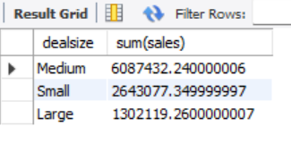

1. **Best Month For Sale Per Year:**

**->** select month_id , year_id, sum(sales) from sales_data where year_id = 2003 group by month_id , year_id order by sum(sales) desc limit 1 ;

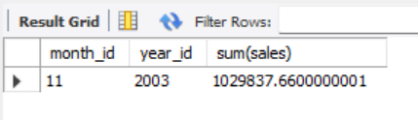

**->** select month_id , year_id, sum(sales) from sales_data where year_id = 2004 group by month_id , year_id order by sum(sales) desc limit 1 ;

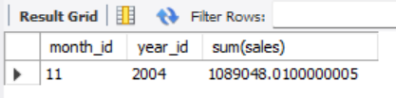

**->** select month_id , year_id, sum(sales) from sales_data where year_id = 2005 group by month_id , year_id order by sum(sales) desc limit 1 ;

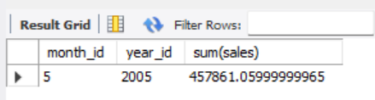

1. **Top 3 Customers On The Basis of Sales as per productline:**

**->** with

cte as

(select productline , customername, sum(sales) "total_sales" from sales_data group by productline , customername)

select * from (select *, row_number() over (partition by productline order by total_sales desc) "top3_customers" from cte) A

where top3_customers<= 3;

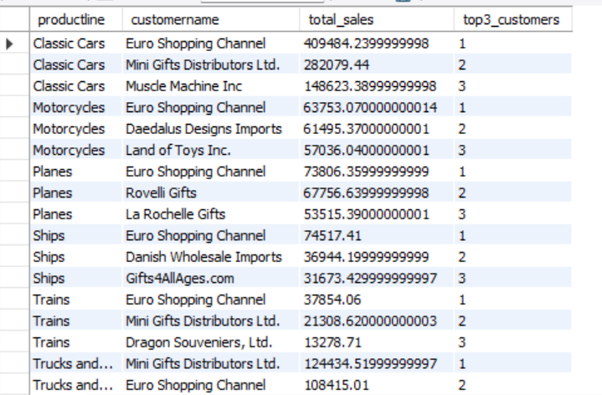

1. **Top 3 Customers on the Basis of Total Number of Orders as Per Productline:**

**->** with

cte1 as

(select productline , customername, count(ordernumber) "frequency" from sales_data group by productline , customername)

select * from (select *, row_number() over(partition by productline order by frequency desc) "top3_customers" from cte1) B

where top3_customers<= 3;

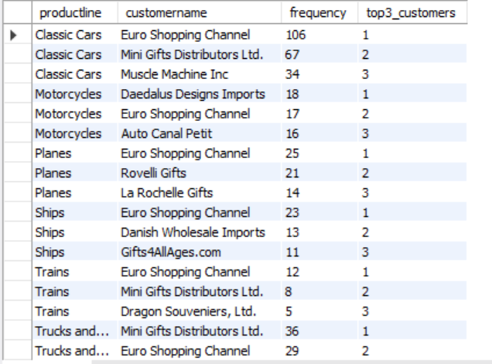

**B.** **Problem Statement (Graphical Representation on Tableau):**

**1-> A Packet bubble chart is required to be created that illustrates the total revenue of each productline.**

**2> A Packet bubble chart is required to be created that illustrates the total revenue of each year.**

**3> A Pie chart is required to be created that illustrates the total revenue of each Dealsize.**

**4> A Bar chart is required to be created that illustrates the total revenue of each Year with specific month.**

**5> A Horizontal Bar chart is required to be created highlighting the revenue of each Country.**

**6> A Horizontal Bar chart is required to be created highlighting the revenue generated from each Customer Countrywise.**

The following Dashboard which is made on Tableau Pubic answers all the problem mentioned above.

Dashboard link-

[Book13 | Tableau Public](https://public.tableau.com/app/profile/yash.bajaj6473/viz/Book13_16952010894620/Dashboard1?publish=yes)

